**Lab Assignment 2**

**Paul Sender**

**3/28/2021**

**Problem Description:**

The problem at hand was to successful link and implement a javascript file in order to run validation on a form that was set up in the HTML document.

**Analysis:**

* In order to keep the HTML as preserved as possible, the only things I changed were moving the script tag to after the form as it would not load quick enough and gave the license accept div a name so I could access it and update its styling. Knowing now that I could have edited the HTML more, I would have given the input fields ID’s so I could utilize document.getElementById instead of document.getElementsByName. By ID would have been better because HTML can contain elements that have the same name, and my code would have changed the styles of all those elements, not just the one I wanted.
* I encountered difficulty when trying to access the form at first. I needed to move the script tag to below the form as the script loaded faster than the form and therefore would not recognize the form.
* I also needed to figure out how to change the className of an element in a form and to do that I used the document.getElementsByName[“name”].classList.add(“css-class-name”).
* I needed to preventDefault in each of the cases instead of once at the beginning in order for users to be able to resubmit the form after correcting their mistakes.
* I also added a window.scroll(0,0) to show the user the form wasn’t submitted and all the places that needed to be updated. Another good addition would have been a section to list all of the error messages. An array was used to set this up.

**Source Code:**

<!DOCTYPE html>

<html>

<head lang="en">

   <meta charset="utf-8">

   <title>Form + JavaScript</title>

   <link rel="stylesheet" href="lab7_problem1.css" />

</head>

<body>

   <form method="get" action="" id="mainForm">

      <fieldset>

         <legend>Photo Details</legend>

         <table>

            <tr>

               <td colspan="2">

                  <p>

                     <label>Title</label><br />

                     <input type="text" name="title" size="80" class="required"/>

                  </p>

                  <p>

                     <label>Description</label><br />

                     <textarea name="description" rows="5" cols="61" class="required"></textarea>

                  </p>

               </td>

            </tr>

            <tr>

               <td>

                  <p>

                     <label>Continent</label><br />

                     <select name="continent">

                        <option>Choose continent</option>

                        <option>Africa</option>

                        <option>Asia</option>

                        <option>Europe</option>

                        <option>North America</option>

                        <option>South America</option>

                     </select>

                  </p>

                  <p>

                     <label>Country</label><br />

                     <select name="country">

                        <option>Choose country</option>

                        <option>Canada</option>

                        <option>Mexico</option>

                        <option>United States</option>

                     </select>

                  </p>

                  <p>

                     <label>City</label><br />

                     <input type="text" name="city" list="cities" size="40" />

                     <datalist id="cities">

                        <option>Calgary</option>

                        <option>Montreal</option>

                        <option>Toronto</option>

                        <option>Vancouver</option>

                     </datalist>

                  </p>

               </td>

               <td>

                  <div class="box">

                     <label>Copyright? </label><br />

                     <input type="radio" name="copyright" value="1">All rights reserved<br />

                     <input type="radio" name="copyright" value="2" checked>Creative Commons<br />

                  </div>

                  <div class="box">

                     <label>Creative Commons Types </label><br />

                     <input type="checkbox" name="cc">Attribution <br />

                     <input type="checkbox" name="cc">Noncommercial <br />

                     <input type="checkbox" name="cc">No Derivative Works <br />

                     <input type="checkbox" name="cc">Share Alike

                  </div>

               </td>

            </tr>

            <tr>

               <td colspan="2">

                  <div class="rectangle" name="softwareaccept">

                     <label>I accept the software license</label>

                     <input type="checkbox" name="accept" class="required">

                  </div>

               </td>

            </tr>

            <tr>

               <td>

                  <p>

                     <label>Rate this photo: <br />

                        <input type="number" min="1" max="5" name="rate" />

                  </p>

                  <p>

                     <label>Color Collection: <br />

                        <input type="color" name="color" />

                  </p>

               </td>

               <td>

                  <div class="box">

                     <p>

                        <label>Date Taken: <br />

                           <input type="date" name="date" />

                     </p>

                     <p>

                        <label>Time Taken: <br />

                           <input type="time" name="time" />

                     </p>

                  </div>

               </td>

            </tr>

            <tr>

               <td colspan="2">

                  <div class="rectangle centered">

                     <input type="submit" class="rounded"> <input type="reset" value="Clear Form" class="rounded">

                  </div>

               </td>

            </tr>

         </table>

      </fieldset>

   </form>

   <script type="text/javascript" src="lab7_problem1.js"></script>

</body>

</html>

var form = document.getElementById("mainForm")

form.onsubmit = function (e) {

    var formData = new FormData(form)

    var errors = []

    if (formData.get("title") === '') {

        e.preventDefault();

        errors.push("Title is empty")

        document.getElementsByName("title")[0].classList.add("blank")

    }

    if (formData.get("description") === '') {

        e.preventDefault();

        errors.push("Description is empty")

        document.getElementsByName("description")[0].classList.add("blank")

    }

    if(formData.get("accept") === null) {

        errors.push("Please accept the software license")

        document.getElementsByName("softwareaccept")[0].classList.add("blank")

    }

    if (errors.length > 0) {

        window.scroll(0, 0)

        return

    }

}

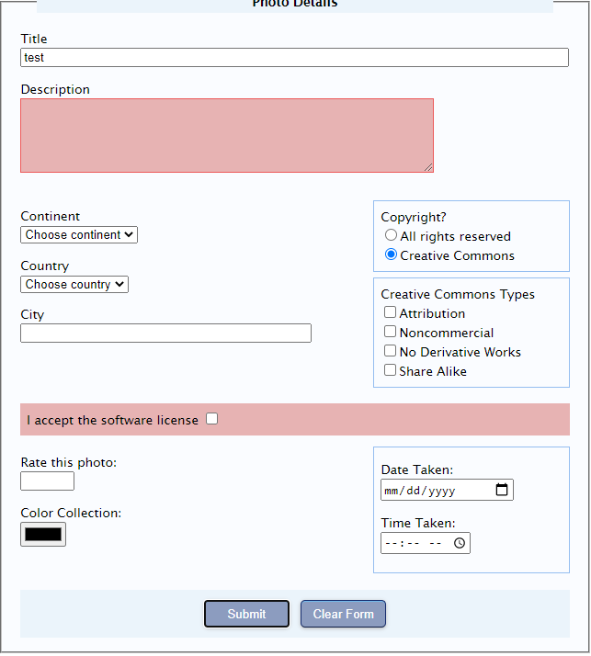**:**

**INTRO TASKS**

